Claudio S. Castillo

CTS 2451

Prof. Norge Pena

01/12/18

**Visual Studio 2017 Installation and Galactic Database Setup**

Visual Studio 2017 could be downloaded from the website: <https://visualstudio.microsoft.com/vs/>. I chose the community edition because it is a free version of the IDE even though it has some limitations.

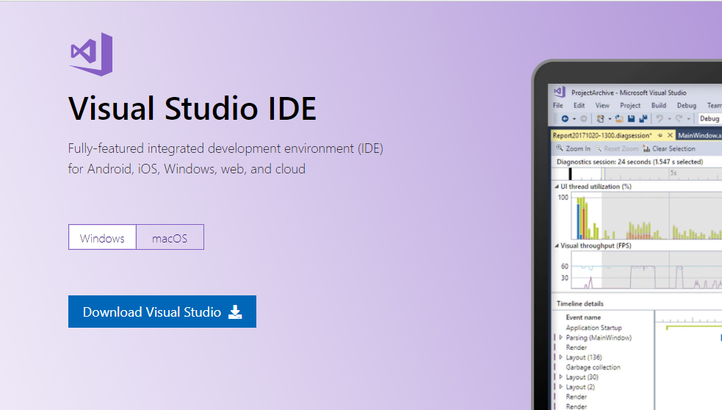

After installed the program it will be prompted another window where we select those components we need to add to the environment. Since the purpose of this project is to work with SSRS then we need to make sure we select the “Data Storage and Processing” option. Doing that we are adding to Visual Studio (VS) IDE, the ability to include the Data Tools.

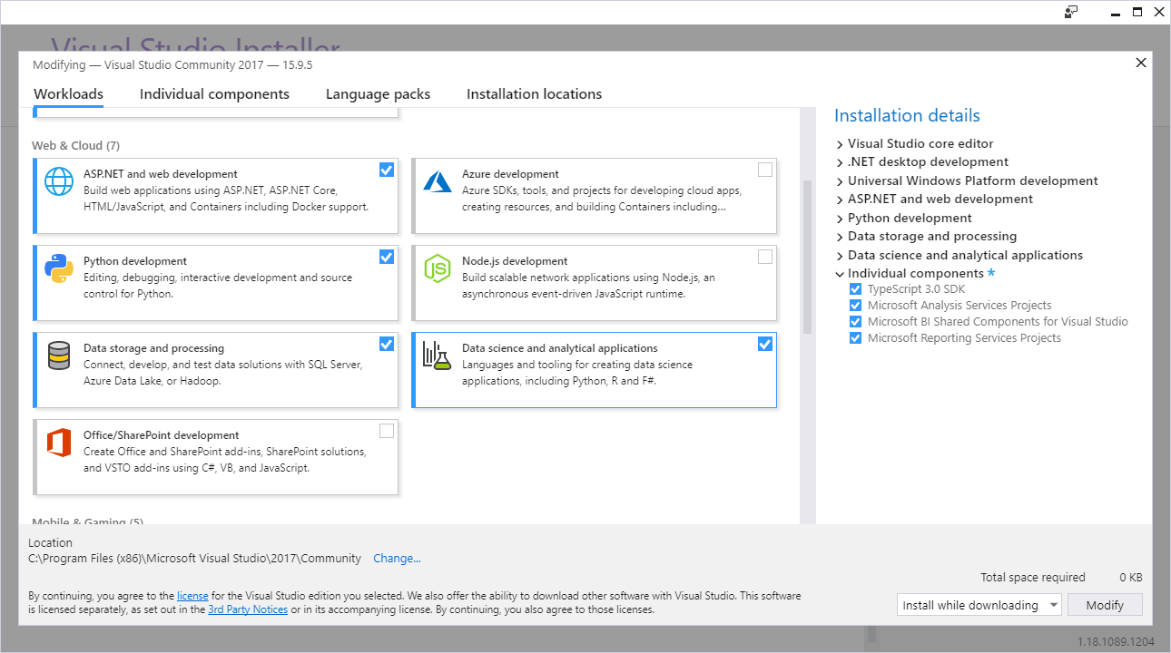

Although we already added the Data Tools to VS IDE, the sub-menu “Business Intelligence” still not showing up as a drop down:

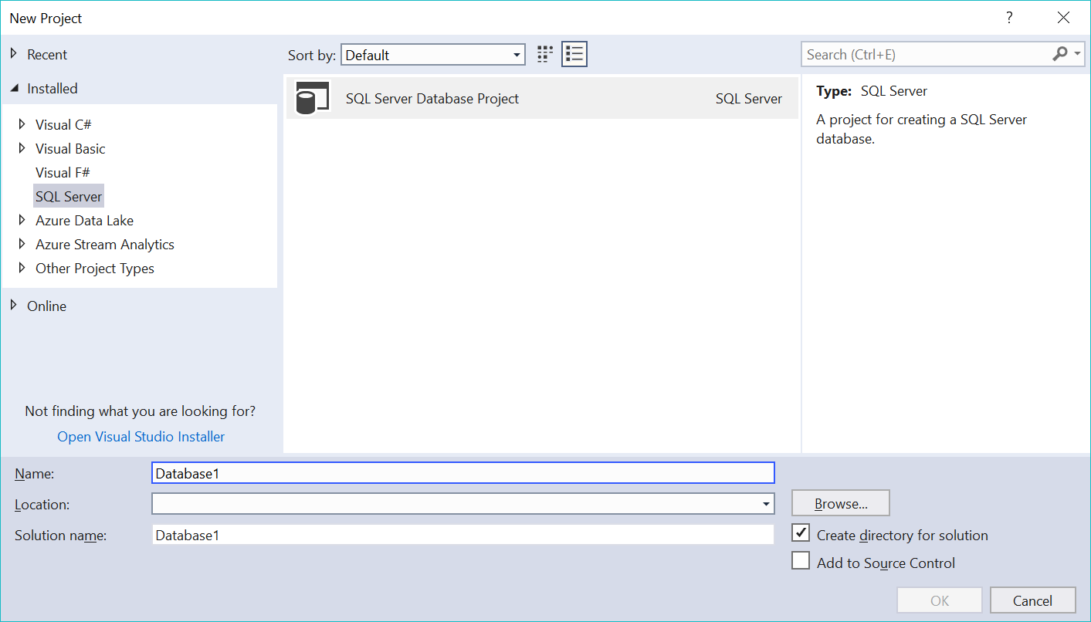

There are two ways of doing that: it could be downloaded from the web an installer called “SSDT-Setup-ENU.exe”. From there we can choose the instance we are adding those components and the SQL Server features. This is shown in the following image:

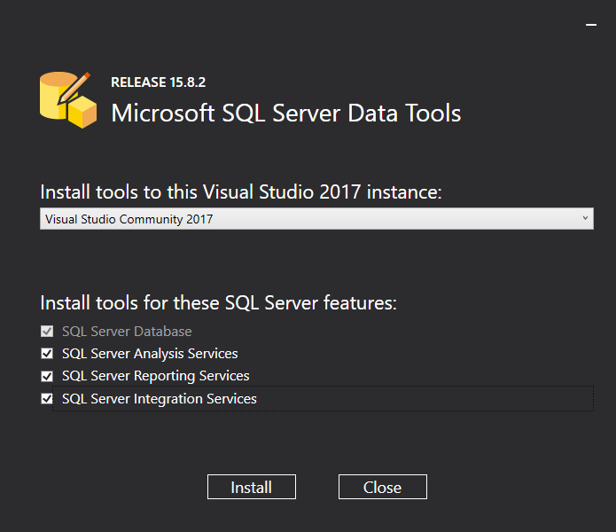

A second way of doing that is adding extensions to our VS IDE. I chose this option because I had some issues with the previous one. I downloaded the two extensions needed:

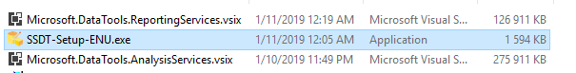

After performing these steps, we are ready to expand the “Business Intelligence” dropdown sub-menu where we can select the Reporting Services Option. As displayed in the following image we can now select between the Wizard and a raw Report.

Up to this point we are ready to continue to the attachment of the Galactic Database. First of all, we can download the .bak file from this site: <https://github.com/csco90/SSRS-Projects>.

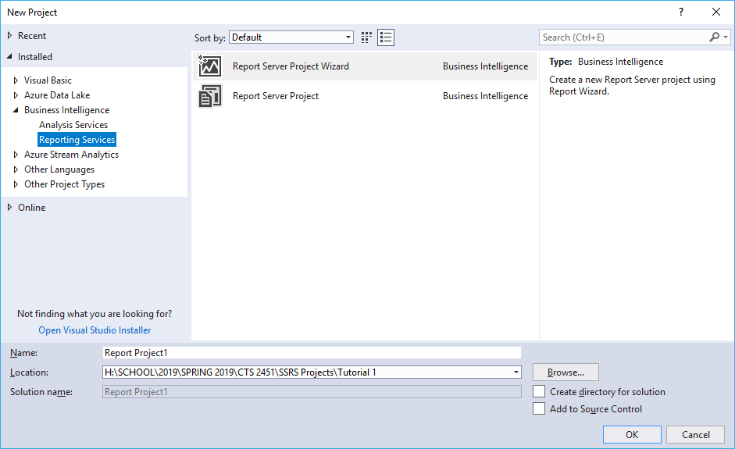

After downloading the database, we need to add to our SQL Server. To perform that step we open our SSMS that we already setup for previous semesters and then connect to the database engine:

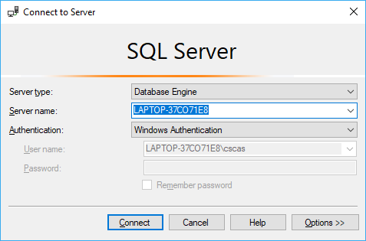

Then we go to the object explorer, right click Database folder and select “Restore Database” option from the dropdown. The next step would be to select “Device” and then we select the add file as shown in the next pictures.

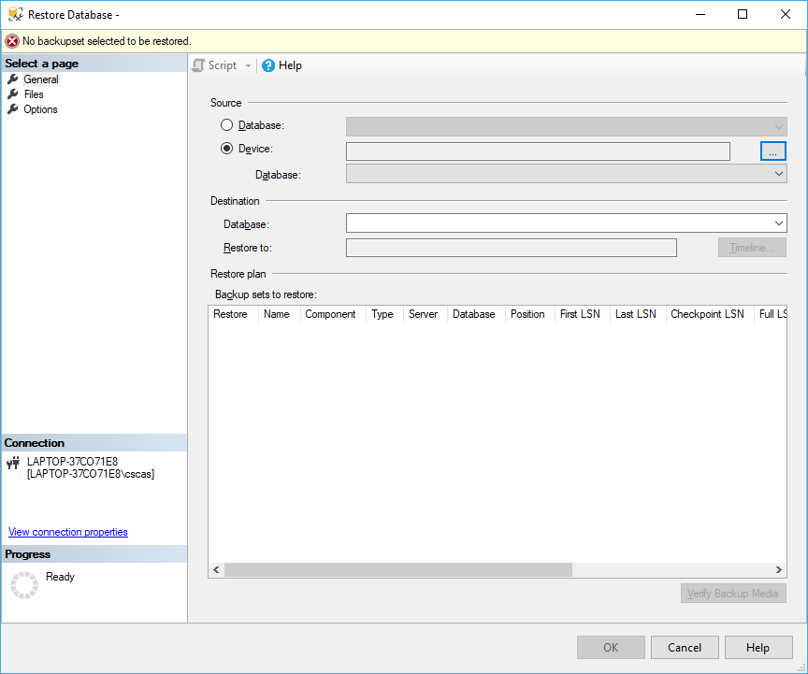

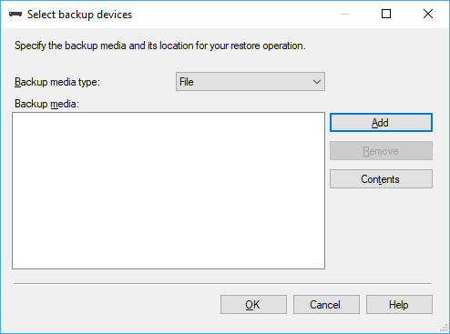

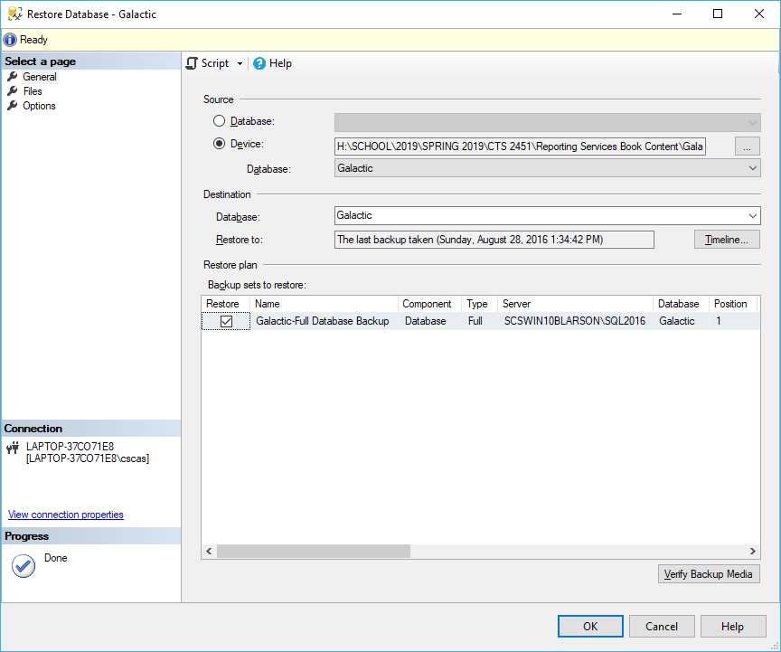

After clicking “OK” we will have the Galactic Database Attached to our SQL Server and the only steps left will be to have it in our VS 2017 Environment. We can now close the SSMS and go back to VS 2017.

Even though we have our SSMS closed we still can connect to any database that we have attached to it from the Visual Studio environment and use it to create a Report.

To demonstrate such task, we are going to create a data source (Database) and a dataset (Query) that can be used to generate Reports using the Galactic Database we just attached.

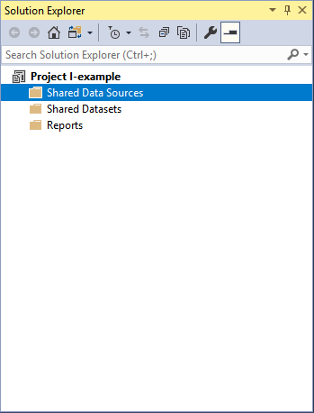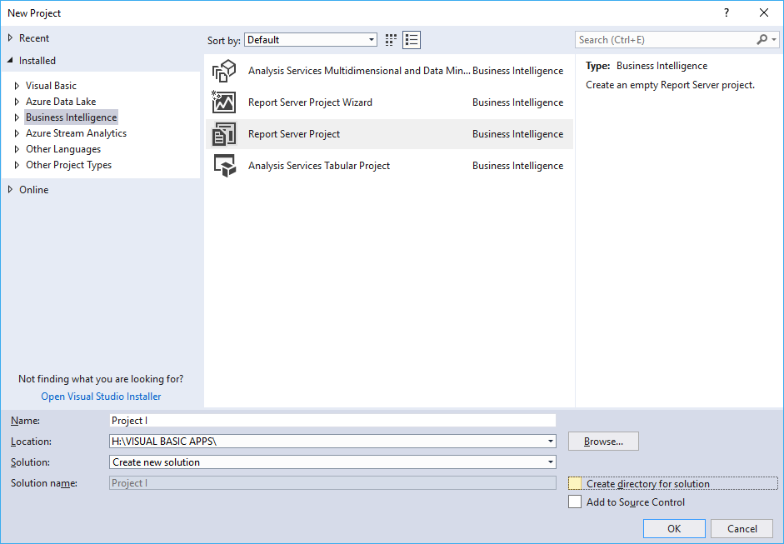Open the Visual Studio 2017 and from the File dropdown select “new project”. A new window will be shown where we need to select the Business Intelligence option and then Report Server Report Project from the items displayed. We selected this option because we don’t want the wizard to be prompted, we just want to add a data source and a dataset to our solution.

After creating a new solution (project) we will be able to see three different folders in the “Solution Explorer” window: “Shared data sources” where we will find the Databases connected to our reports; Shared datasets where we will find the queries used; and of course, the Reports folders. Because one of the goals of this project is to demonstrate we can connect the Galactic Database to the Visual Studio Environment then we are going to focus on the first two Folders.

Right click the Shared Data Sources folder and then select Add new Data Source. A new window will pop up when we must give a name to the data source we are creating. Since we are going to connect to the Galactic Database is a good practice to give it the same name.

Click on the Edit button, set to Microsoft SQL Server the type of data source from the dropdown menu. We are connecting to the local server we have in our machine so there is no need to type or find the server name we just can type “.”. Select windows authentication and then select the Galactic database.

As shown in the next figure, a box message of successful connection will be popped up after clicking the Test Connection button.

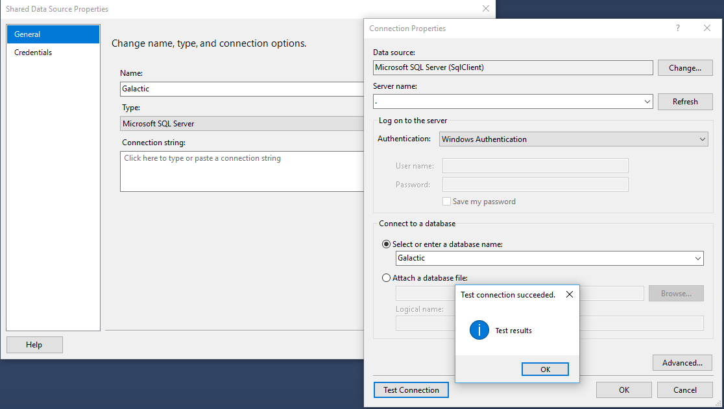

Adding a New Dataset (Query) is very similar. First, right click on the Shared Dataset folder and click on Add a New Dataset. A Window will be popped up where we must give a name to that dataset and select the data source (which will be Galactic because is the Data Source we just created in the previous step.)

Later we click on the Query Designer when we just select the tables and the field we need to add into the report later. Click OK and then we will have the dataset (query) that will feed with data our report.

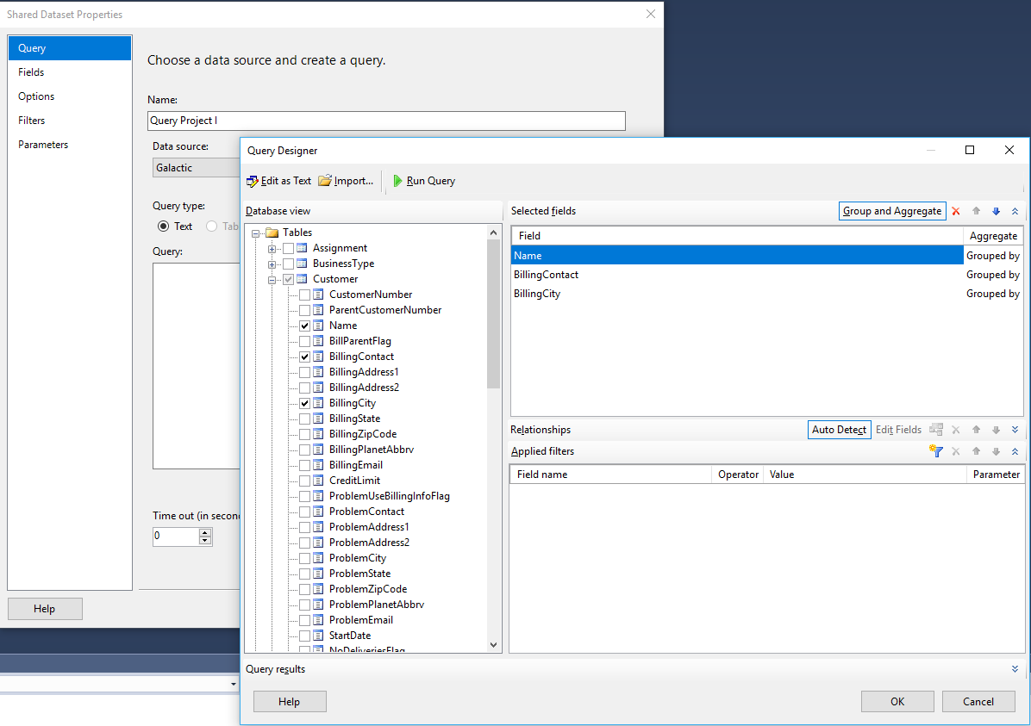

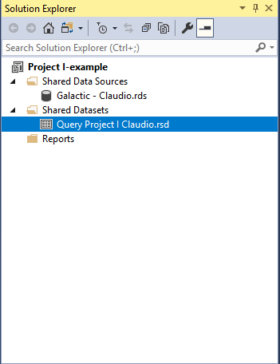After this point we just need to start creating our reports because we have the data source and the dataset linked in our Visual Studio 2017 environment.